EXPT NO:5A
DATA VISUALIZATION USING MATPLOTLIB
– DRIVER STANDINGS DATA
Aim:
To visualize Driver Standings dataset features and distributions using line charts, bar charts, pie charts, histograms, scatter plots, and box plots using Matplotlib.
Algorithm:
ALGORITHM 1: LINE CHART
Objective: To visualize the maximum points of top driver IDs.
Steps
1. Load the Driver Standings dataset.
2. Group the data by Driver ID and calculate maximum points.
3. Plot the maximum points using a line chart.
4. Add title and axis labels.
5. Display the graph.
Interpretation
The line chart shows the maximum points associated with the top driver IDs and helps compare their point values.
ALGORITHM 2: BAR CHART
Objective: To compare maximum points across top driver IDs.
Steps
1. Group the dataset by Driver ID.
2. Calculate maximum points for each driver.
3. Create a bar chart using the top driver values.
4. Add title and axis labels.
5. Display the chart.
Interpretation
The bar chart helps compare maximum points across different driver IDs.
ALGORITHM 3: PIE CHART
Objective: To visualize the distribution of maximum points among top driver IDs.
Steps
1. Select the maximum point values of the top driver IDs.
2. Create a pie chart using the point values.
3. Display percentage labels.
4. Add a suitable title.
5. Display the chart.
Interpretation
The pie chart shows the percentage contribution of each selected driver ID to the total maximum points.
ALGORITHM 4: HISTOGRAM
Objective: To visualize the distribution of driver points.
Steps
1. Select the Points column.
2. Divide the points values into bins.
3. Create a histogram.
4. Add title and axis labels.
5. Display the histogram.
Interpretation
The histogram shows the frequency distribution of driver points.
ALGORITHM 5: SCATTER PLOT
Objective: To visualize the relationship between points and wins.
Steps
1. Select Points as the X-axis variable.
2. Select Wins as the Y-axis variable.
3. Create a scatter plot.
4. Add title and axis labels.
5. Display the graph.
Interpretation
The scatter plot shows the variation and relationship between driver points and wins.
ALGORITHM 6: BOX PLOT
Objective: To visualize the distribution of driver points.
Steps
1. Select the Points column.
2. Create a box plot.
3. Add a suitable title and axis label.
4. Display the plot.
Interpretation
The box plot shows the distribution of points and helps identify possible outliers.
ALGORITHM 7: MULTIPLE LINE CHARTS
Objective: To compare maximum points and maximum wins for top driver IDs.
Steps
1. Group the data by Driver ID.
2. Calculate maximum points and maximum wins.
3. Plot the points using one line chart.
4. Plot wins using another line chart.
5. Add title, axis labels and legend.
6. Display the graph.
Interpretation
The multiple line chart compares maximum points and wins across selected driver IDs.

CODE:
import pandas as pd
import matplotlib.pyplot as plt

df = pd.read_csv("driver_standings(1).csv", low_memory=False)
driver_points = df.groupby("driverId")["points"].max().sort_values(ascending=False).head(10)

# Program 1: Line Chart
plt.plot(driver_points.index.astype(str), driver_points.values, marker="o")
plt.title("Maximum Points by Top Driver IDs")
plt.xlabel("Driver ID")
plt.ylabel("Maximum Points")
plt.grid()
plt.show()

# Program 2: Bar Chart
plt.bar(driver_points.index.astype(str), driver_points.values)
plt.title("Top Driver IDs by Maximum Points")
plt.xlabel("Driver ID")
plt.ylabel("Maximum Points")
plt.xticks(rotation=45)
plt.show()

# Program 3: Pie Chart
plt.pie(driver_points.values, labels=driver_points.index.astype(str), autopct="%1.1f%%")
plt.title("Top 10 Driver IDs - Points Share")
plt.show()

# Program 4: Histogram
plt.hist(df["points"].dropna(), bins=15)
plt.title("Driver Points Distribution")
plt.xlabel("Points")
plt.ylabel("Frequency")
plt.show()

# Program 5: Scatter Plot
plt.scatter(df["points"], df["wins"], s=12)
plt.title("Points vs Wins")
plt.xlabel("Points")
plt.ylabel("Wins")
plt.show()

# Program 6: Box Plot
plt.boxplot(df["points"].dropna(), vert=False)
plt.title("Driver Points Box Plot")
plt.xlabel("Points")
plt.show()

# Program 7: Multiple Line Charts
top5 = driver_points.head(5)
top5_wins = df.groupby("driverId")["wins"].max().reindex(top5.index)
x = range(len(top5))
plt.plot(x, top5.values, marker="o", label="Maximum Points")
plt.plot(x, top5_wins.values, marker="o", label="Maximum Wins")
plt.title("Maximum Points and Wins - Top Driver IDs")
plt.xlabel("Driver ID")
plt.ylabel("Value")
plt.xticks(list(x), top5.index.astype(str))
plt.legend()
plt.grid()
plt.show()

Output:
Line Chart
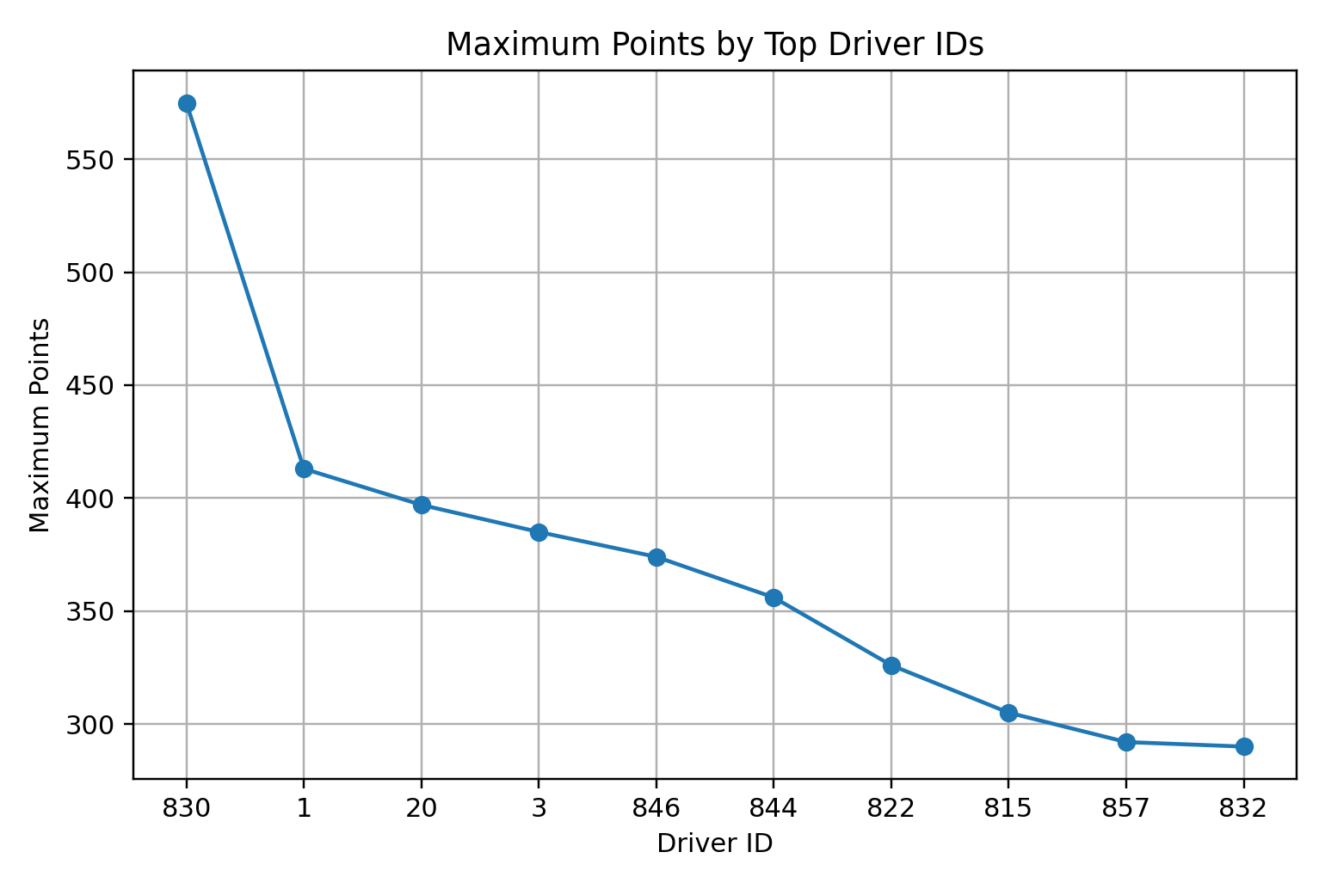
Bar Chart
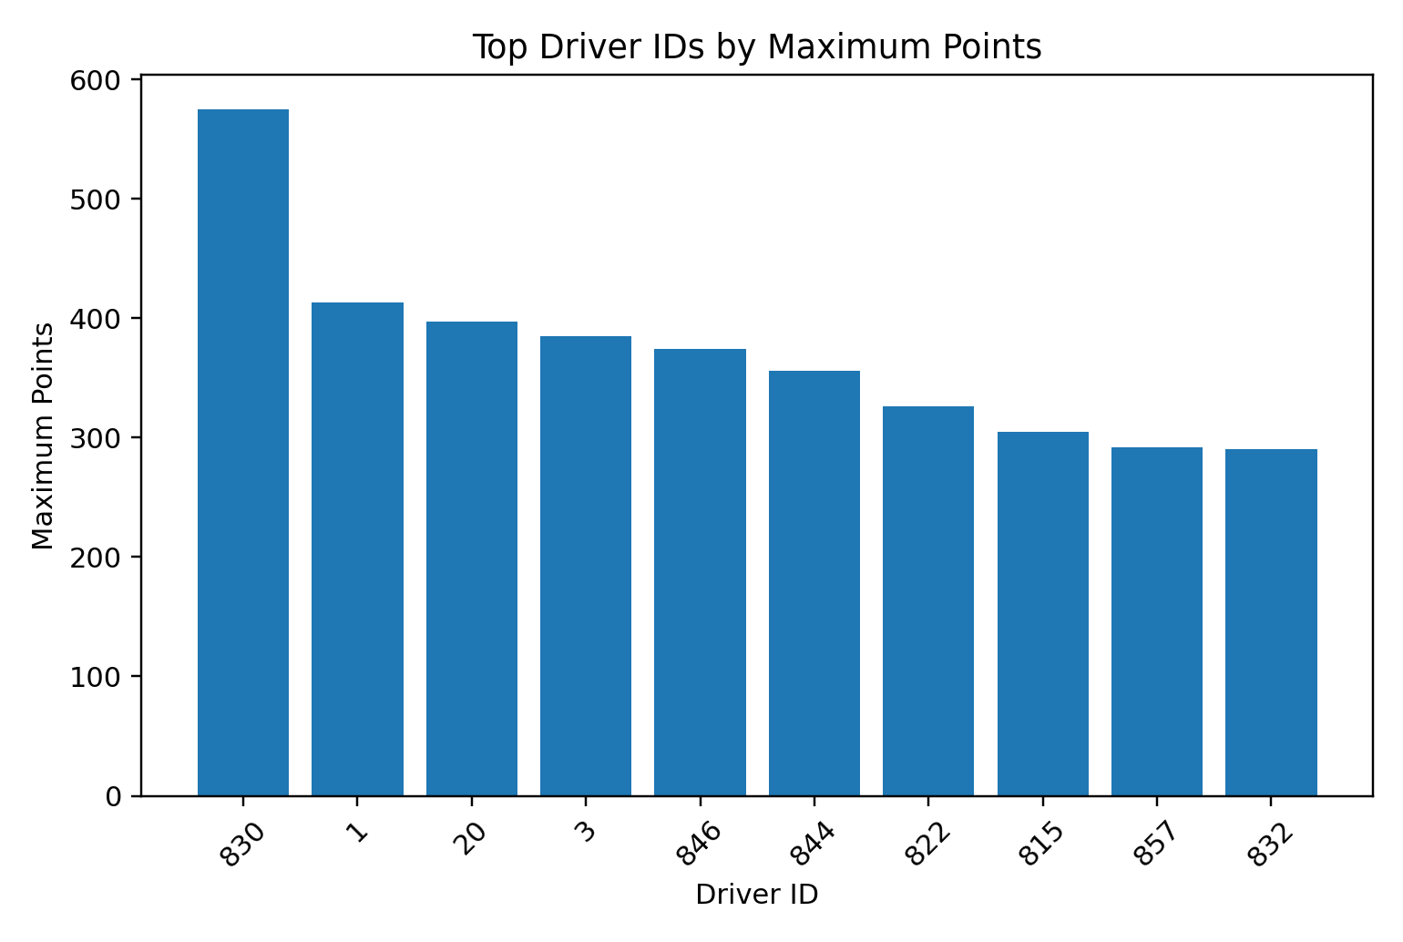

Output:
Pie Chart
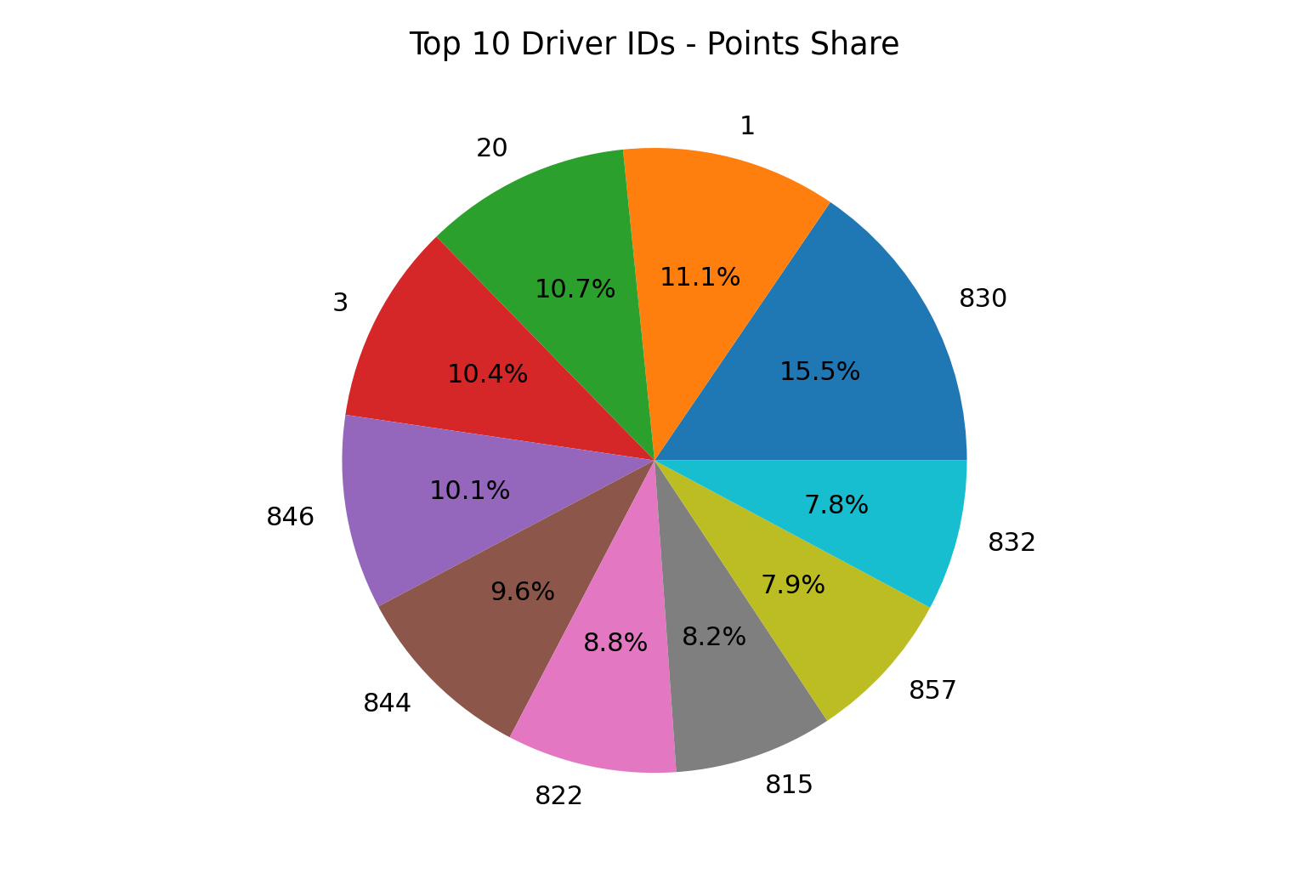
Histogram
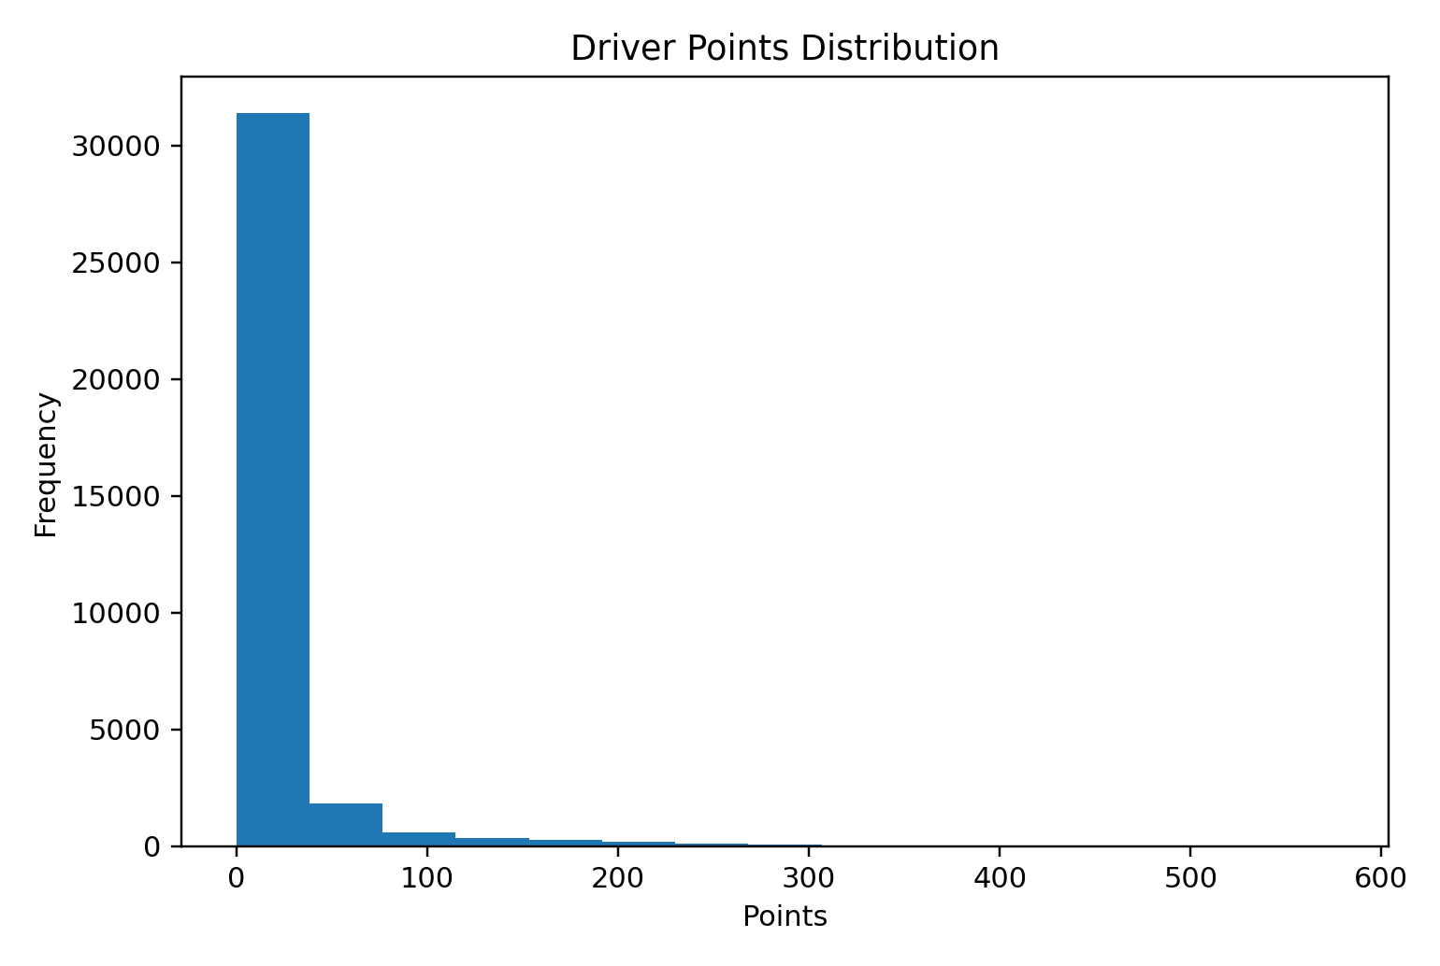

Output:
Scatter Plot
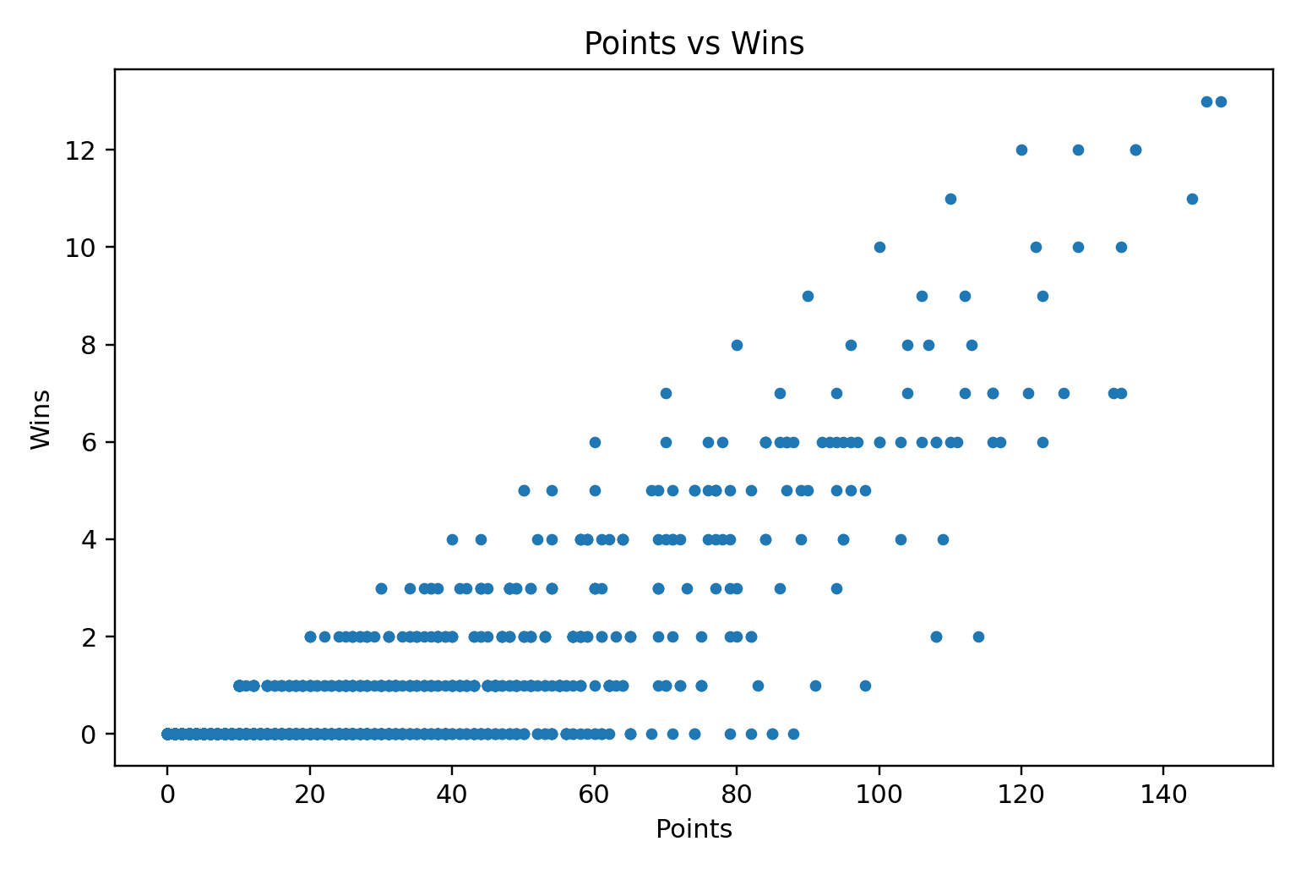
Box Plot
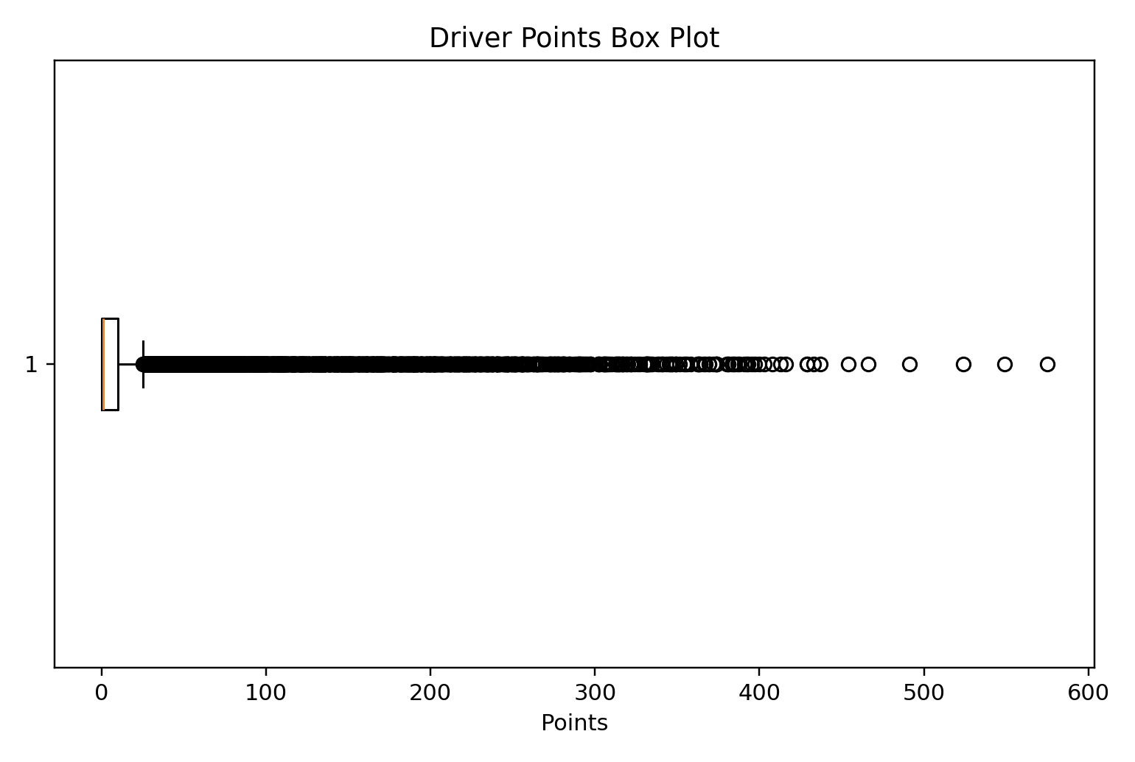

Output:
Multiple Line Charts
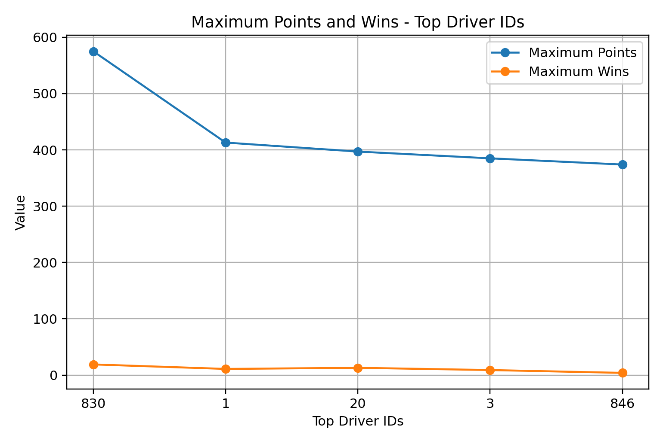
Result:
The Driver Standings dataset was successfully visualized using line, bar, pie, histogram, scatter, box, and multiple line charts. The graphs provide visual understanding of driver points, wins, and their distributions.

EXPT NO:5B
DATA VISUALIZATION
AIM:
To visualize the Driver Standings dataset using Python and create different charts to understand driver performance, points distribution, wins, and important patterns.
PROCEDURE:
1. Start the program.
2. Import Pandas, Matplotlib, and Seaborn libraries.
3. Load the Driver Standings CSV dataset.
4. Display the first few records using head().
5. Identify the numerical columns using select_dtypes().
6. Create a bar chart to compare the top driver IDs based on maximum wins.
7. Create a line chart to analyze points of the first 20 standings records.
8. Create a pie chart to show the maximum-wins share of the top 10 driver IDs.
9. Create a box plot to identify the distribution and outliers in wins.
10. Create a histogram to observe the frequency distribution of wins.
11. Add suitable titles, axis labels, legends, and grid lines.
12. Display all the visualizations.
13. Analyze the graphs and identify important patterns.
14. Stop the program.

CODE:
import pandas as pd
import matplotlib.pyplot as plt
import seaborn as sns

# Load Driver Standings dataset
df = pd.read_csv("driver_standings(1).csv", low_memory=False)
print("Dataset Preview:")
display(df.head())

# Select numerical columns
num_cols = df.select_dtypes(include="number").columns
print("\nNumerical columns:")
print(num_cols.tolist())

# 1. BAR CHART
top10 = df.groupby("driverId")["wins"].max().sort_values(ascending=False).head(10)
plt.figure(figsize=(10,5))
plt.bar(top10.index.astype(str), top10.values)
plt.title("Driver Standings - Top 10 Driver IDs by Maximum Wins")
plt.xlabel("Driver ID")
plt.ylabel("Maximum Wins")
plt.xticks(rotation=45)
plt.tight_layout()
plt.show()

# 2. LINE CHART
first20 = df.head(20)
plt.figure(figsize=(9,5))
plt.plot(range(1, len(first20)+1), first20["points"], marker="o")
plt.title("Driver Standings - Points of First 20 Records")
plt.xlabel("Record")
plt.ylabel("Points")
plt.grid()
plt.tight_layout()
plt.show()

# 3. PIE CHART
plt.figure(figsize=(7,7))
plt.pie(top10, labels=top10.index.astype(str), autopct="%1.1f%%")
plt.title("Driver Standings - Top 10 Wins Share")
plt.tight_layout()
plt.show()

# 4. BOX PLOT
plt.figure(figsize=(8,5))
sns.boxplot(y=df["wins"])
plt.title("Driver Standings - Wins Box Plot")
plt.ylabel("Wins")
plt.tight_layout()
plt.show()

# 5. HISTOGRAM
plt.figure(figsize=(8,5))
plt.hist(df["wins"], bins=15)
plt.title("Driver Standings - Wins Histogram")
plt.xlabel("Wins")
plt.ylabel("Frequency")
plt.tight_layout()
plt.show()

Output:
Bar Chart
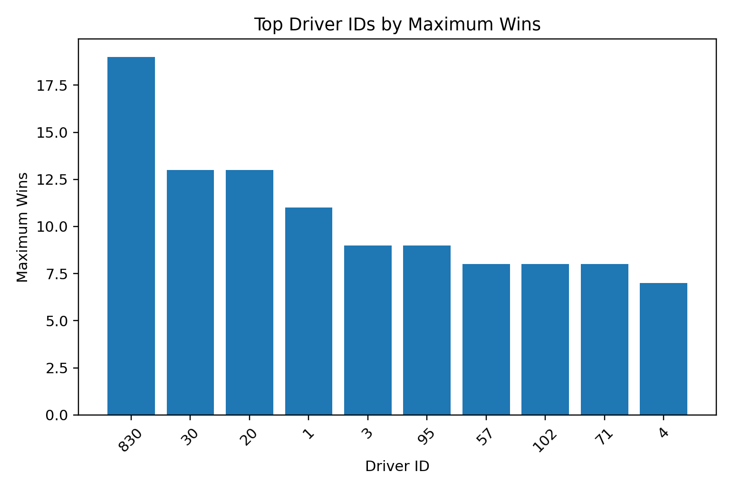
Line Chart
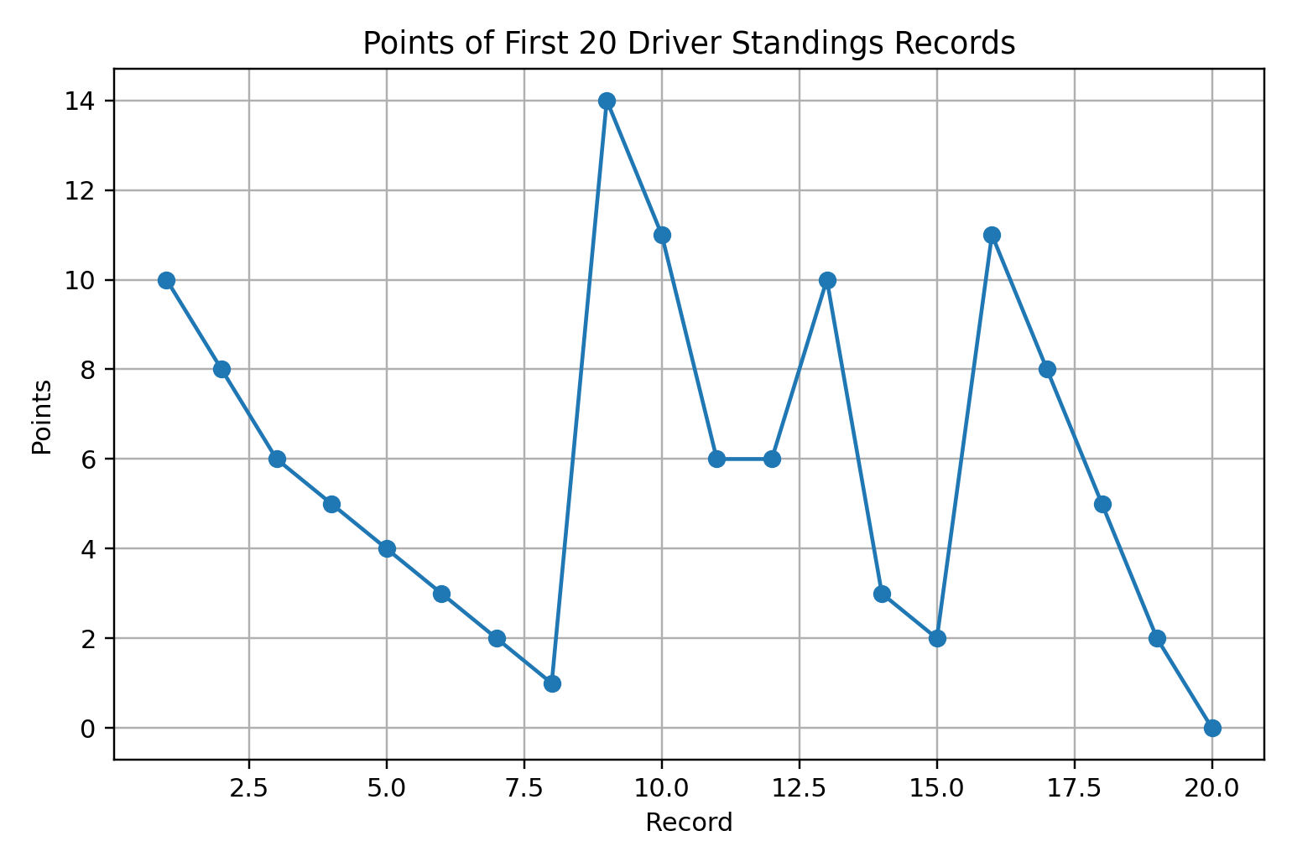

Output:
Pie Chart
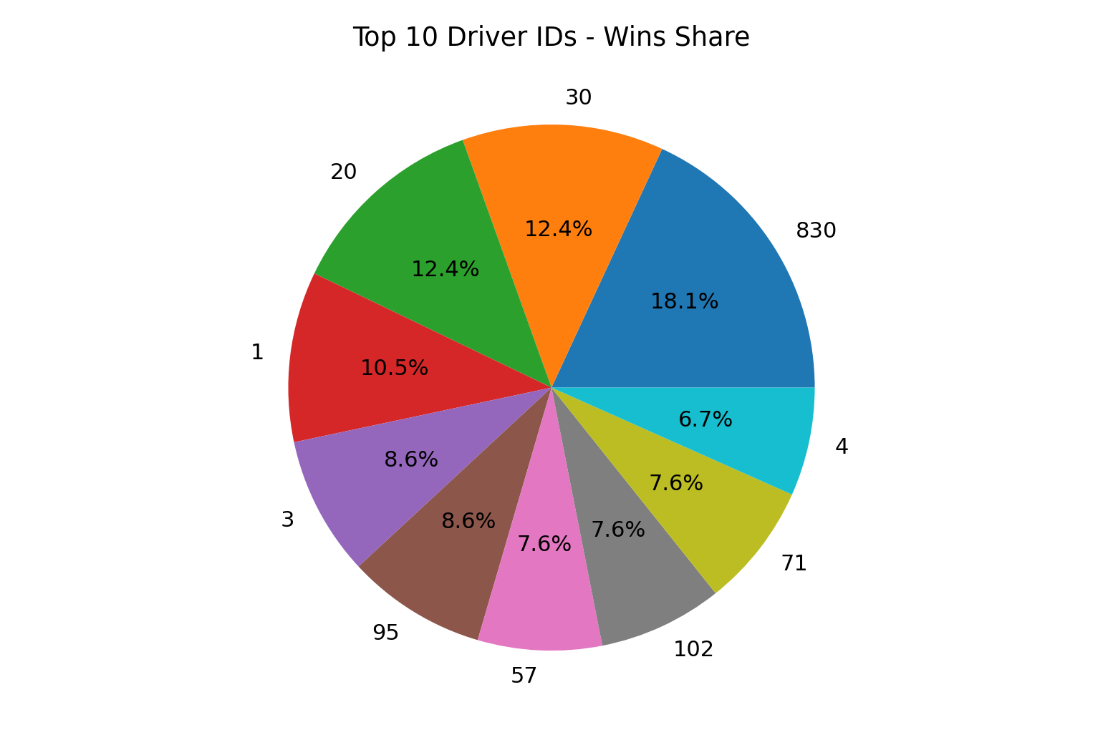
Box Plot
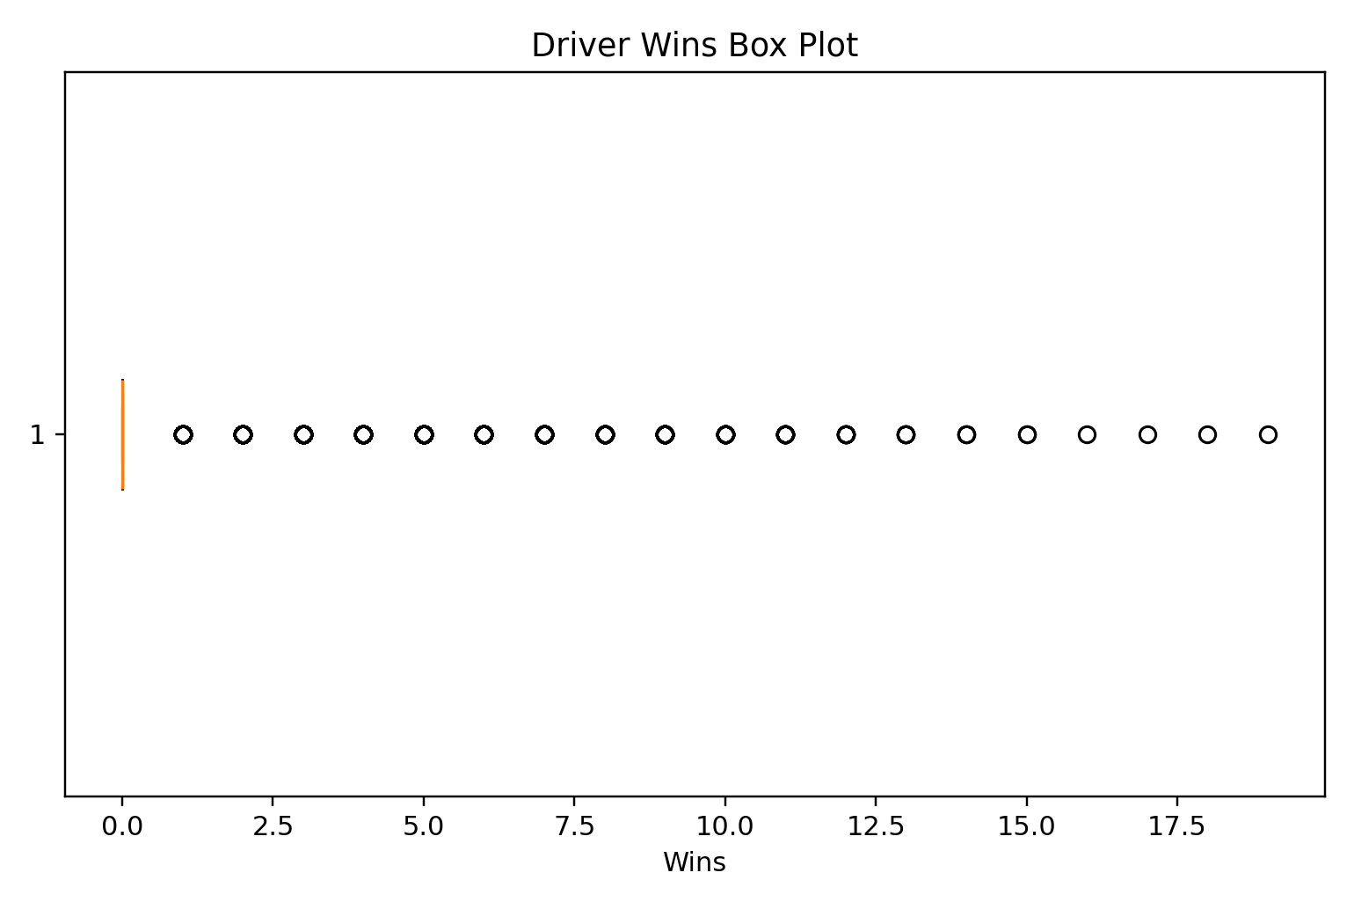

Output:
Histogram
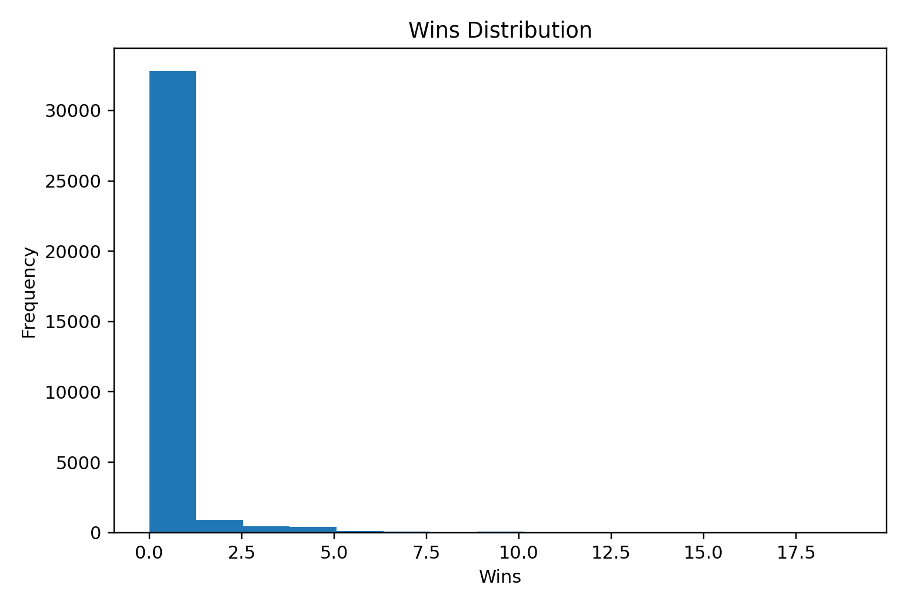
Result:
The Driver Standings dataset was successfully visualized using bar, line, pie, box, and histogram charts. The visualizations provide a clear view of driver wins, points across records, the distribution of wins, and the presence of possible outliers.

